|  |
| --- |
|   **SCHOOL OF APPLIED SCIENCES DEPARTMENT OF COMPUTER SCIENCE** A PROJECT REPORT  on  “REAL TIME EMOTION DETECTION”  Submitted in partial fulfillment of the requirements for the award of the Degree of    BACHELOR OF SCIENCE    Submitted by    **Ms. MADHU SHREE .M (R19PC317)**  **Ms. NIVEDITHA.V (R19PC328)**  **Ms. B SUMAN WATI (R19PC305)**    Under the Guidance of  Prof. Swathi M Pai  Assistant Professor  August 2022  Rukmini Knowledge Park, Kattigenahalli, Yelahanka, Bengaluru -560064  [www.reva.edu.in](http://www.reva.edu.in/) |

# DECLARATION

I, Ms. Madhu Shree M student of BSc (P, M, Cs) to School of Applied Sciences, REVA University, declare that the Project Report / Dissertation entitled *“*REAL TIME EMOTION DETECTION” is the result the of project / dissertation work done by me under the supervision of Dr / Prof. Swathi M Pai at department of computer sciences school of applied science, REVA UNIVERSITY.

I am submitting this Project Report / Dissertation in partial fulfillment of the requirements for the award of the degree of Bachelor of Science in P, M, Cs by the REVA University, Bangalore during the academic year 2021-2022.

I declare that this project report has been tested for plagiarism, and has passed the plagiarism test with the similarity score less than 25% and it satisfies the academic requirements in respect of Project work prescribed for the said Degree.

I further declare that this project / dissertation report or any part of it has not been submitted for award of any other Degree / Diploma of this University or any other University/ Institution.

(Signature of the candidate)

Signed by me

I certify that this project work submitted by **Madhu Shree M** has been carried out under my guidance and the declaration made by the candidate is true to the best of my knowledge.

Signature of Guide Signature of Co-Guide (if any)

Signature of Deputy Director

School of Applied Sciences

**SCHOOL**

**OF**

**APPLIED**

**SCIENCES**

**CERTIFICATE**

Certified

that the project work

**entitled**

**REAL TIME EMOTION DETECTION**

**carried**

out under my guidance

by

**Madhu Shree M (R19PC317)**

**)**

, a bona

fide

student of REVA University

during the academic year

202

1

-

2

2

,

is

submitting the project report in partial fulfillment for the award

of

Bachelor

**of Science in**

**P,**

**M, Cs**

during

the

academic

year

202

1

-

2

2

.

The

project

report

has

been

tested

for

plagiarism,

and

has

passed

the plagiarism test with the similarity score less than 25%. The

project report has been approved as

it

satisfies the

academic

requirements in

respect

of

Project

work

prescribed

for

the

said

Degree.

**<**

**Guide**

**name**

**>**

**co**

**<**

**-**

**guide**

**name**

**>**

**Head**

**of**

**the**

**Department**

**Deputy Director**

**School**

**of**

**Applied**

**Sciences**

**REVA**

**University,**

**Bangalore**

**-**

**560064**

**Name**

**of the**

**Examiner**

**Signature**

**with**

**date**

1.

2.



# TABLE OF CONTENTS

ABSTRACT

ABOUT PROJECT

## 1.INTRODUCTION

INTRODUCTION OF PROJECT

1.1 BREIF DESCRIPTION OF PROJECT

1.2 OBJECTIVES

1.3 SCOPE

1.4 MOTIVATION

1.5 PROBLEM STATEMENTS

## 2. REQUIREMENT ANALYSIS

2.1FUNCTIONAL REQUIREMENTS

2.2 NON-FUNCTIONAL REUIREMENTS

## 3. PROJECT METHODOLOGY

3.1 SYSTEM DESIGN

3.2 SYSTEM FLOWCHART

3.3 FLOECHART TRAINING

3.4 SEQUENCE DIAGRAM

3.5 EXPRESSION RECOGNITON

## 4. CLASSIFICATION

4.1 SUPPORT VECTOR MECHINE

4.2 SYSTEM EVALUATION

### 5. REQUIRENMENT ANALYSIS

5.1 PLANNING

5.2 LITERATURAL REVIEW

5.3 SOFTEARE AND HARDWARE REQUIRENMENTS

### 6. DATA COLLECTION

6.1 COHN-KANADE AU CODED FACIAL EXPRESSION

DATABASE

6.2 JAPANESE FEMALE FACIAL EXPRESSION (JAFFE)

DATABASE

### 7. DEVELOPMENT AND TESDTING

7.1 FRAMEWORK

7.2 SYSTEM TESTING

7.3 CODING

## 8. EXPERIMENTATION AND RESULTS

8.1 EXPERIMENTATION

8.2 SCREENSHOTS

8.3 CONCLUSION AND RECOMMENDATION

8.4 FUTURESCOPE

8.5 REFERENCES

### ABSTRACT

Facial Expression conveys non-verbal cues, which plays an important role in interpersonal relations. The Facial Expression Recognition system is the process of identifying the emotional state of a person.

In this system captured image is compared with the trained dataset available in database and then emotional state of image will be displayed.

This system is based on image processing and machine learning. For designing a robust facial future descriptor, we apply the Local Binary Pattern. Local Binary Pattern (LBP) is a simple yet very efficient texture operator which labels the pixels the pixels of an image by thresholding the neighborhood of each pixel and considers the results as a binary number.

The recognition performance of the proposed method will be evaluated by using the trained database with the help of Support Vector Machine. Experimental results with prototypic expressions show the superiority of the LBP descriptor against some well-known appearance-based feature representation methods.

ABOUT PROJECT

In today’s networked world the need to maintain security of information or physical property is becoming both increasingly important and increasingly difficult. In countries like Nepal the rate of crimes are increasing day by day. No automatic systems are there that can track person’s activity. If we will be able to track Facial expressions of persons automatically then we can find the criminal easily since facial expressions changes doing different activities. So we decided to make a Facial Expression Recognition System.

We are interested in this project after we went through few papers in this area. The papers were published as per their system creation and way of creating the system for accurate and reliable facial expression recognition system.

As a result, we are highly motivated to develop a system that recognizes facial expression and track one person’s activity.

### CHAPTER 1

### INTRODUCTION

**1.1 Brief introduction of Real Time Emotion Detection**

A Facial expression is the visible manifestation of the affective state, cognitive activity, intention, personality and psychopathology of a person and plays a communicative role in interpersonal relations. It has been studied for a long period of time and obtaining the progress recent decades. Though much progress has been made, recognizing facial expression with a high accuracy remains to be difficult due to the complexity and varieties of facial expressions.

Generally human beings can convey intentions and emotions through nonverbal ways such as gestures, facial expressions and involuntary languages. This system can be significantly useful, nonverbal way for people to communicate with each other. The important thing is how fluently the system detects or extracts the facial expression from image. The system is growing attention because this could be widely used in many fields like lie detection, medical assessment and human computer interface.

On day-to-day basics humans commonly recognize emotions by characteristic features, displayed as a part of a facial expression. For instance, happiness is undeniably associated with a smile or an upward movement of the corners of the lips. Similarly other emotions are characterized by other deformations typical to a particular expression. Research into automat.

The system classifies facial expression of the same person into the basic emotions namely anger, disgust, fear, happiness, sadness and surprise. The main purpose of this system is efficient interaction between human beings and machines using eye gaze, facial expressions, cognitive modeling etc. And the system intensity varies from person to person and also varies along with age, gender, size and shape of face, and further, even the expressions of the same person do not remain constant with time. Page | 2

#### 1.2 Objectives

The main objectives of this project are:

1. To develop a facial expression recognition system.
2. To experiment machine learning algorithm in computer vision fields.
3. To detect emotion thus facilitating Intelligent Human-Computer Interaction.

1.3 Scope

The scope of this project is as follows:

1. The system can be used to detect and track a user’s state of mind.
2. The system can be used in mini-marts, shopping center to view the feedback of the customers to enhance the business,
3. The system can be installed at busy places like airport, railway station or bus station for detecting human faces and facial expressions of each person. If there are any faces that appeared suspicious like angry or fearful, the system might set an internal alarm.
4. The system can also be used for educational purpose such as one can get feedback on how the student is reacting during the class.
5. This system can be used for lie detection amongst criminal suspects during interrogation
6. This system can help people in emotion related -research to improve the processing of emotion data.
7. Clever marketing is feasible using emotional knowledge of a person which can be identified by this system.

#### 1.4 Motivation

In today’s networked world the need to maintain security of information or physical property is becoming both increasingly important and increasingly difficult. In countries like Nepal the rate of crimes are increasing day by day. No automatic systems are there that can track person’s activity. If we will be able to track Facial expressions of persons automatically then we can find the criminal easily since facial expressions changes doing different activities. So, we decided to make a Facial Expression Recognition System. We are interested in this project after we went through few papers in this area. The papers were published as per their system creation and way of creating the system for accurate and reliable facial expression recognition system.

As a result, we are highly motivated to develop a system that recognizes facial expression and track one person’s activity.

#### 1.5 Problem Statements

Human emotion and intentions are expressed through facial expressions and deriving an efficient and effective feature is the fundamental component of facial expression system. Face recognition is important for the interpretation of facial expressions in applications such as intelligent, man-machine interface and communication, intelligent visual surveillance, teleconference and real-time animation from live motion images. The facial expressions are useful for efficient interaction Most research and system in facial expression recognition are limited to six basic expressions (joy, sad, anger, disgust, fear, surprise). It is found that it is insufficient to describe all facial expressions and these expressions are categorized based on facial actions.

Detecting face and recognizing the facial expression is a very complicated task when it is a vital to pay attention to primary components like: face configuration, orientation, location where the face is set.

### CHAPTER 2

### REQUIRENMENTS ANALYSIS

#### 2.1 Functional Requirements

The functional requirements for a system describe what the system should do. Those requirements depend on the type of software being developed, the expected users of the software. These are statement of services the system should provide, how the system should react to particular inputs and how the system should behave in particular situation.

#### 2.2 Non-Functional Requirements

Nonfunctional requirements are requirements that are not directly concerned with the specified function delivered by the system. They may relate to emergent system properties such as reliability, response time and store occupancy. Some of the nonfunctional requirements related with this system are hereby below:

1. **Reliability:**

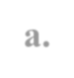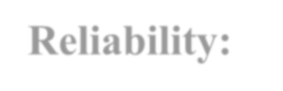

Reliability based on this system defines the evaluation result of the system, correct identification of the facial expressions and maximum evaluation rate of the facial expression recognition of any input images.

1. 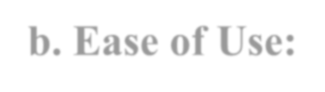**Ease of Use:**

The system is simple, user friendly, graphics user interface implemented so any can use this system without any difficulties.

### CHAPTER 3

### PROJECT METHODOLOGY

#### 3.1 System Design

System design shows the overall design of system. In this section we discuss in detail the design aspects of the system:

##### System Diagram

Training

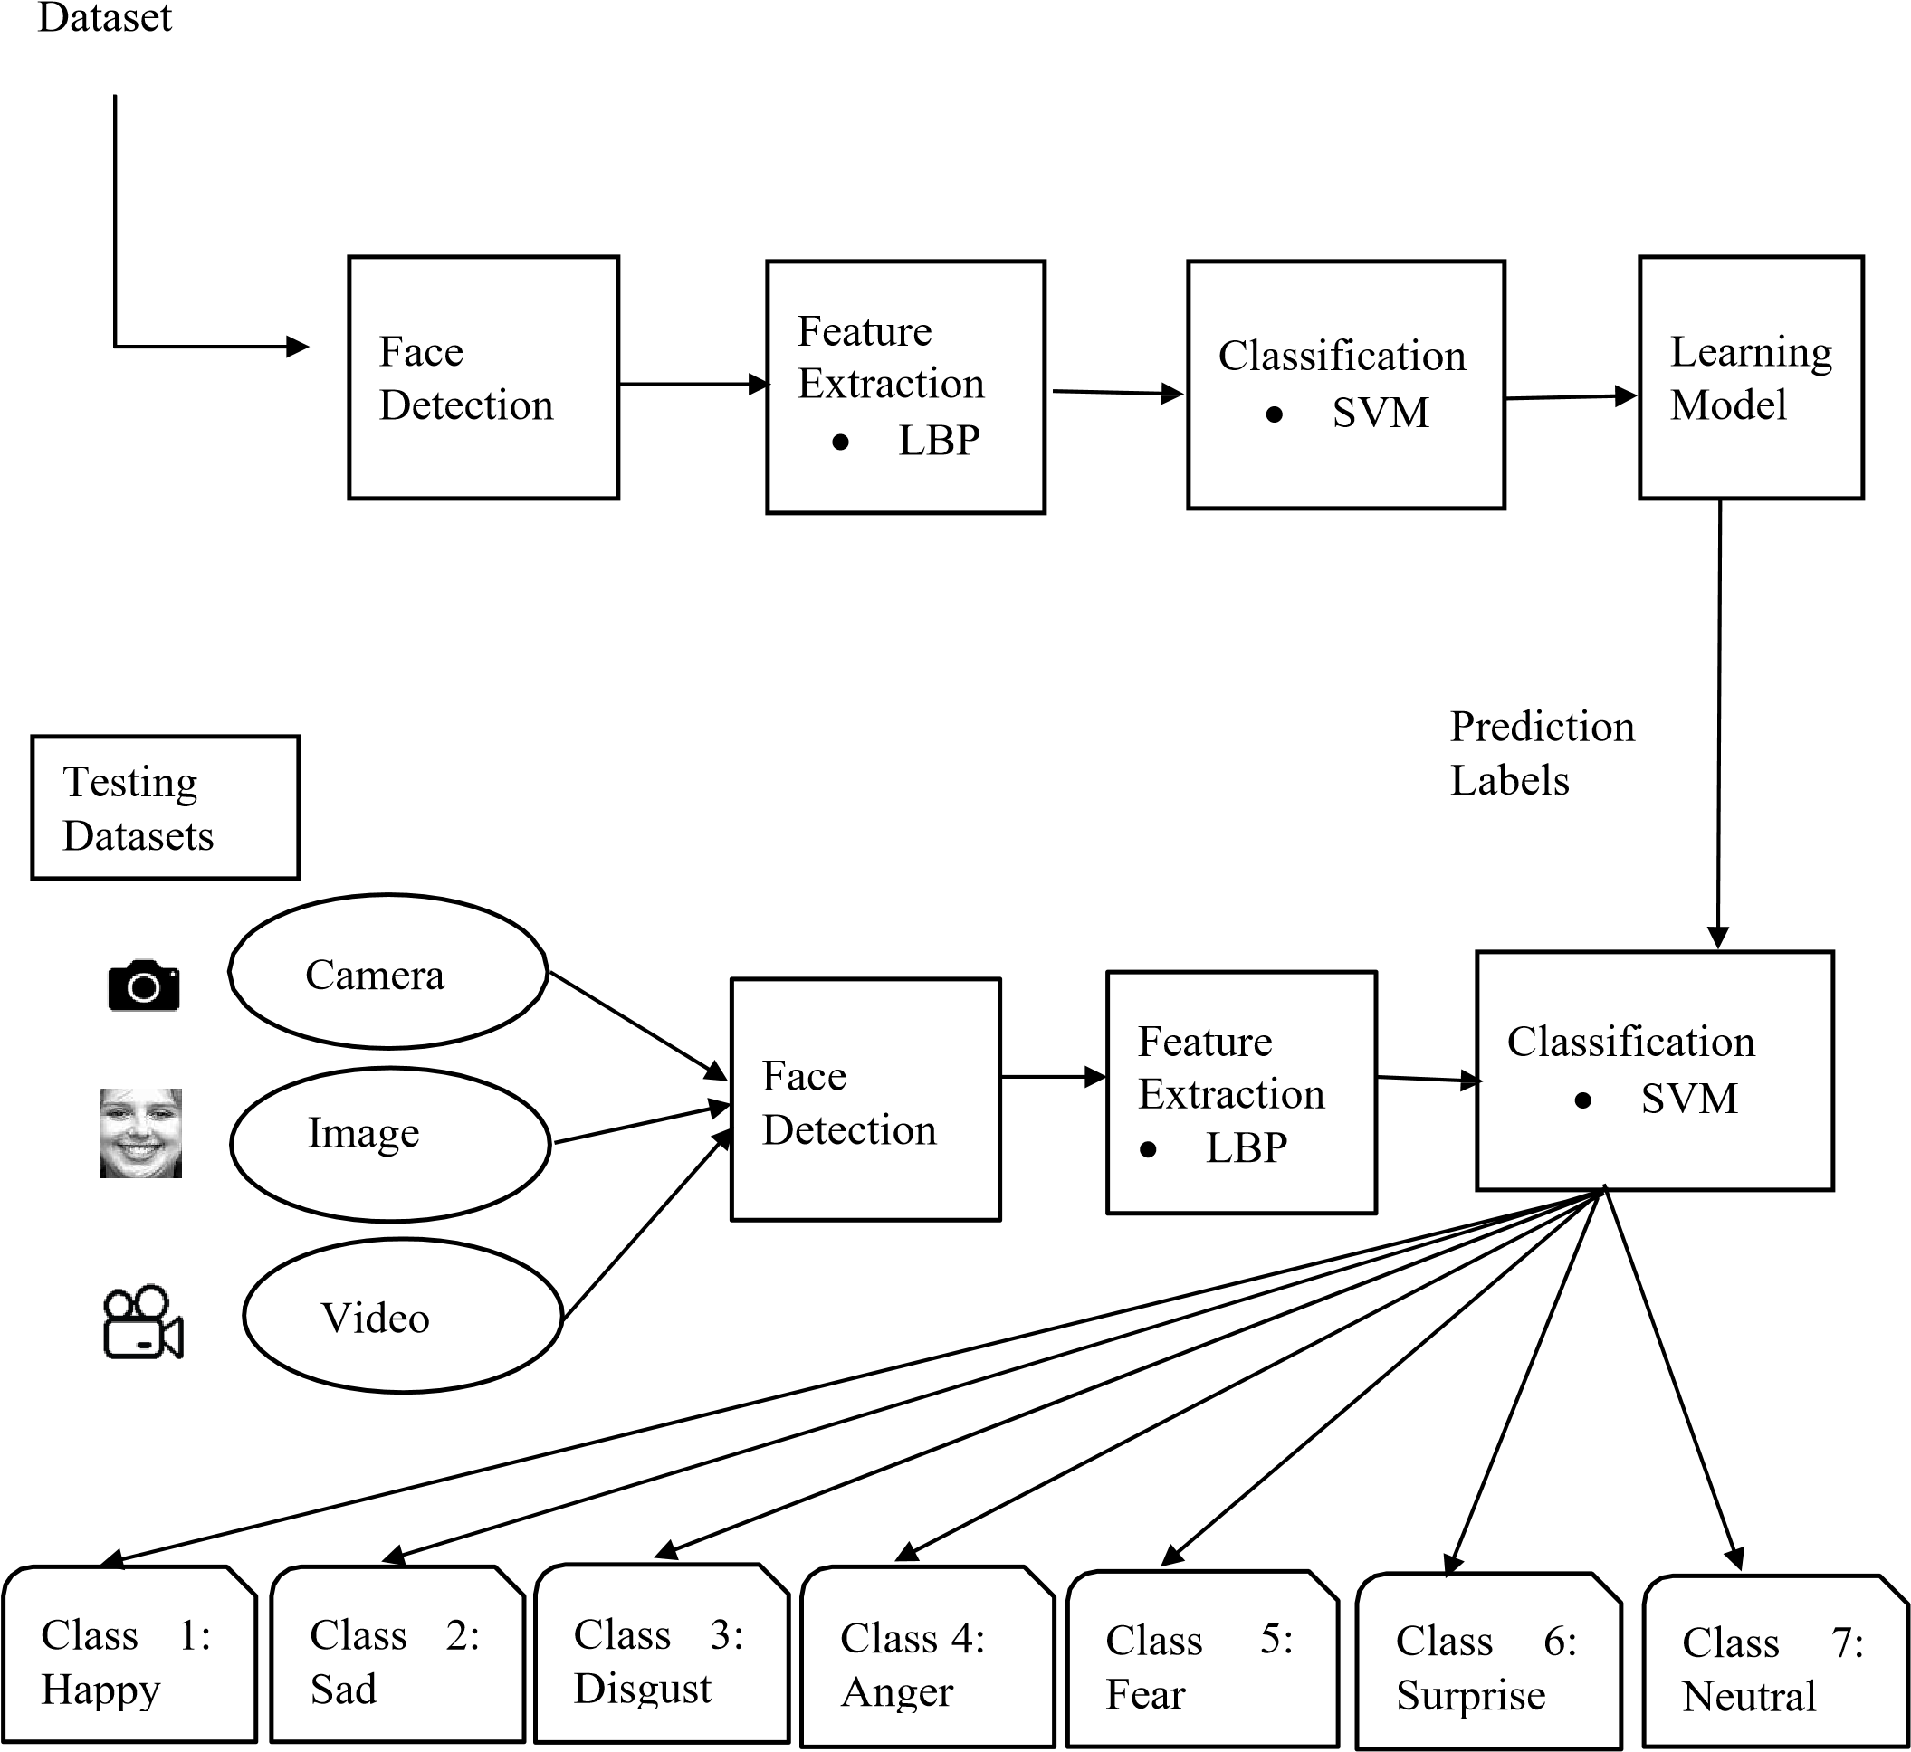

**Figure 1: System Diagram**

#### 

#### 3.2 System Flowchart



Start



Cropped Face and

aligned

Dataset

Image

Preprocessing

Feature Extraction

Training SVM

Trained Model

**Figure 2: System flowchart**

#### 3.3 Flowchart of Training



Start



Input

Image

Face

Detection

Image

Preprocessing

Feature

Extraction

|  |  |  |  |
| --- | --- | --- | --- |
| |  | | --- | | Trained Model | | |  | | --- | | SVM | |

Recognition result

**Figure 3: Flowchart of Testing/Prediction**

#### 3.4 Sequence Diagram

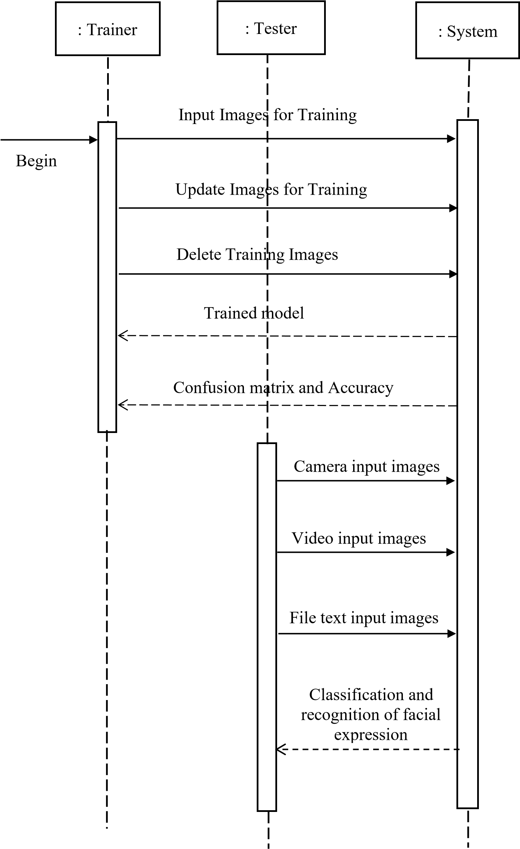

**Figure 4: Sequence Diagram**

#### 3.5 Phases in Facial Expression Recognition

The facial expression recognition system is trained using supervised learning approach in which it takes images of different facial expressions. The system includes the training and testing phase followed by image acquisition, face detection, image preprocessing, feature extraction and classification. Face detection and feature extraction are carried out from face images and then classified into six classes belonging to six basic expressions which are outlined below:

#### Image Acquisition

Images used for facial expression recognition are static images or image sequences. Images of face can be captured using camera.

#### Face detection

Face Detection is useful in detection of facial image. Face Detection is carried out in training dataset using Haar classifier called Voila-Jones face detector and implemented through OpenCV. Haar like features encodes the difference in average intensity in different parts of the image and consists of black and white connected rectangles in which the value of the feature is the difference of sum of pixel values in black and white regions.

#### Image Pre-processing

Image pre-processing includes the removal of noise and normalization against the variation of pixel position or brightness.

a) Color Normalization

b) Histogram Normalization

##### 3.6 Feature Extraction

Selection of the feature vector is the most important part in a pattern classification problem. The image of face after pre-processing is then used for extracting the important features. The inherent problems related to image classification include the scale, pose, translation and variations in illumination level.

**CHAPTER 4**

### Classification

The dimensionality of data obtained from the feature extraction method is very high so it is reduced using classification. Features should take different values for object belonging to different class so classification will be done using Support Vector Machine algorithm.

#### 4.1 Support Vector Machines

SVM is widely used in various pattern recognition tasks. SVM is a state-of-the art machine learning approach based on the modern statistical learning theory. SVM can achieve a near optimum separation among classes. SVMs is trained to perform facial expression classification using the features proposed. In general, SVM are the maximal hyperplane classification method that relies on results from statistical learning theory to guarantee high generalization performance.

Kernel functions are employed to efficiently map input data which may not be linearly separable to a high dimensional feature space where linear methods can then be applied. SVMs exhibit good classification accuracy even when only a modest amount of training data is available, making them particularly suitable to a dynamic, interactive approach to expression recognition.

An ideal separation is achieved when the hyper plane and the training data of any class is the largest. This separating hyper plane works as the decision surface. SVM has been successfully employed for a number of classification tasks such as text categorization, genetic analysis and face detection. Given a training set of labeled samples:

𝐷 = {(𝑥, 𝑦|𝑥 ϵ𝑅𝑛, 𝑦ϵ {−1,1}} 𝑝=1

**4.2 System Evaluation**

Evaluation of the system can be done using following methods:

##### Precision

Precision estimates the predictive value of a label, either positive or negative, depending on the class for which it is calculated; in other words, it assesses the predictive power of the algorithm. Precision is the percentage of correctly assigned expressions in relation to the total number of aspects.

##### a) Recall

Recall is a function of its correctly classified examples (true positives) and its misclassified examples (false negatives). Recall is the percentage of correctly assigned expressions in relation to the total number of expressions.

##### b) F-score

F-score is a composite measure which benefits algorithms with higher sensitivity and challenges algorithms with higher specificity. The F-score is evenly balanced when β = 1. It favors precision when β > 1, and recall otherwise.

All three measures distinguish the correct classification of labels within different classes. They concentrate on one class (positive examples). Hence, precision and recall do measure different properties and we therefore need a combined quality measure in order to determine the best matching aspect to expression category mappings. The socalled F- measure FM computes the harmonic mean of precision and recall and allows taking into account both properties at the same time [9]. Note that the overall recall recalled is also known as accuracy.

age | 15

### CHAPTER 5

### REQUIREMENT ANALYSIS

#### 5.1 Planning

In planning phase study of reliable and effective algorithms is done. On the other hand, data were collected and were preprocessed for more fine and accurate results. Since huge amount of data were needed for better accuracy, we have collected the data surfing the internet. Since, we are new to this project we have decided to use local binary pattern algorithm for feature extraction and support vector machine for training the dataset. We have decided to implement these algorithms by using OpenCV framework.

##### 5.2 Literature Reviews

Research in the fields of face detection and tracking has been very active and there is exhaustive literature available on the same. The major challenge that the researchers face is the non-availability of spontaneous expression data. Capturing spontaneous expressions on images and video is one of the biggest challenges ahead. Many attempts have been made to recognize facial expressions. Zhang et al investigated two types of features, the geometry-based features and Gabor wavelets-based features, for facial expression recognition.

Appearance based methods, feature invariant methods, knowledge-based methods, Template based methods are the face detection strategies whereas Local Binary Pattern phase correlation, Haar classifier, AdaBoost, Gabor Wavelet are the expression detection strategies in related field [3]. Face reader is the premier for automatic analysis of facial expression recognition and Emotient, Affective, Karios etc. are some of the APIs for expression recognition. Automatic facial expression recognition includes two vital aspects: facial feature representation and classifier problem.

Facial feature representation is to extract a set of appropriate features from original face images for describing faces. Histogram of Oriented Gradient (HOG), SIFT, Gabbor Fitters and Local Binary Pattern (LBP) are the algorithms used for facial feature representation [3,4]. LBP is a simple yet very efficient texture operator which labels the pixels of an image by thresholding the neighborhood of each pixel and considers the result as a binary number. The operator labels the pixels of an image by thresholding the 3X3 neighborhood of each pixel with the center value and considering the result as a binary number. HOG was first proposed by Dalal and Trigs in 2005. HOG numerates the appearance of gradient orientation in a local path of an image.

For classifier problem we use algorithms like Machine learning, Neural Network, Support Vector Machine, Deep learning, Naive Bayes. The formation of histogram by using any of facial feature representation will use Support Vector Machine (SVM) for expression recognition. SVM builds a hyperplane to separate the high dimensional space. An ideal separation is achieved when the distance between the hyper plane and the training data of any class is the largest.

#### 5.3 Software and Hardware Requirements

##### Software Requirement

Following are the software requirement are necessary for the project:

a) Python

1. OpenCV
2. Keras
3. TensorFlow
4. NumPy

##### Hardware Requirement

Following are the hardware requirement that is most important for the project:

1. Fluently working Laptops
2. RAM minimum 4Gb
3. Web Camera

### CHAPTER 6

### Data collection

Some of the public databases to evaluate the facial expression recognition algorithms are:

#### 6.1 COHN-KANADE AU Coded Facial Expression Database

Subjects in the released portion of the COHN-KANADE AU-Coded Facial Expression Database are 100 university students. They ranged in age from 18 to 30 years. Sixty-five percent were female, 15 percent were African-American, and three percent were Asian or Latino. Subjects were instructed by an experimenter to perform a series of 23 facial displays that included single action units and combinations of action units. Image sequences from neutral to target display were digitized into 640 by 480- or 490pixel arrays with 8-bit precision for grayscale values. Included with the image files are "sequence" files; these are short text files that describe the order in which images should be read. The seven expressions are angry, surprise, contempt, fear, and disgust. Fig.1 shows the 8 expressions with each from a different subject.

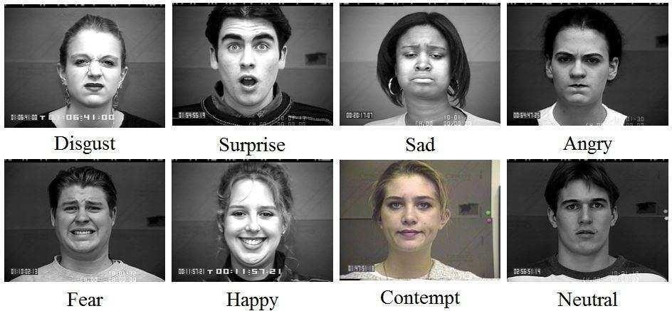

**Figure 1: The eight expressions from one subject**

#### 6.2 Japanese Female Facial Expression (JAFFE) Database

This database contains 213 images in total. There are 10 subjects and 7 facial expressions for each subject. Each subject has about twenty images and each expression includes two to three images. The seven expressions are angry, happy, disgust, sadness, surprise, fear and neutral respectively [4]. Fig.2 shows the seven expressions from one subject.

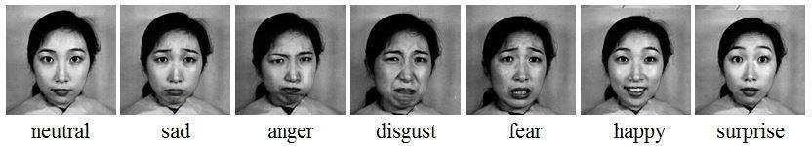

**Figure 2: The seven expressions from one subject**

##### Table 1: Data Collections

|  |  |  |  |
| --- | --- | --- | --- |
| **Database** |  | **Sample Details** | **Available**  **Descriptions** |
| COHN-KANADE  Database (also known as CMU-Pittsburg data- base) [1]. | •  •  •  • | 585 image sequences from 97 subjects  Age: 18 to 30 years  Gender: 65% female  Ethnicity: 15% African - Americans and 3% of Asians and Latinos | “Annotation of  FACS Action  Units and emotion- specified expressions” |
| The Japanese Female  Facial Expression  (JAFFEE) Data-base  [1]. | •  • | 213 images of 7 facial expressions (6 basic facial expressions + 1 neutral) 10 Japanese female models. | “Each image has been rated on 6 emotion adjectives by 92 Japanese subjects” |

### CHAPTER 7

### DEVELOPMENT AND TESTING

#### 7.1 Framework

##### a) OpenCV

OpenCV (Open-Source Computer Vision Library) is an open-source computer vision and machine learning software library. OpenCV was built to provide a common infrastructure for computer vision applications and to accelerate the use of machine perception in the commercial products. Being a BSD-licensed product, OpenCV makes it easy for businesses to utilize and modify the code.

The library has more than 2500 optimized algorithms, which includes a comprehensive set of both classic and state-of-the-art computer vision and machine learning algorithms. These algorithms can be used to detect and recognize faces, identify objects, classify human actions in videos, track camera movements, track moving objects, extract 3D models of objects, produce 3D point clouds from stereo cameras, stitch images together to produce a high resolution image of an entire scene, find similar images from an image database, remove red eyes from images taken using flash, follow eye movements, recognize scenery and establish markers to overlay it with augmented reality, etc. It has C++, C, Python, Java and MATLAB interfaces and supports Windows, Linux, [Android a](http://opencv.org/platforms/android.html)nd Mac OS.

#### 7.2 System Testing

System testing was done by giving different training and testing datasets. This test was done to evaluate whether the system was predicting accurate result or not. During the phase of the development of the system our system was tested time and again.The series of testing conducted are as follows:

##### I. Unit Testing

In unit testing, we designed the whole system in modularized pattern and each module was tested. Till we get the accurate output from the individual module we worked on the same module.

##### II. Integration Testing

After constructing individual modules all the modules were merged and a complete system was made. Then the system was tested whether the prediction given by training dataset to testing set was correct or not. We tried to meet the accuracy as higher as much as we can get. After spending a couple of days in integration testing the average accuracy of our system was 91%.

##### III.Alpha testing

Alpha testing is the first stage of software engineering which is considered as a simulated or actual operational testing done by the individual member of the project.

Alpha testing is conducted by the project developers, in context of our project.

##### IV.Beta Testing

Beta testing comes continuously after alpha testing which is considered as a form of external user acceptance testing. The beta version of the program is developed to and provided to limited audience. This is the final test process in the case of this project.

In this system the beta-testing is done by our colleagues and the project supervisor.

#### 7.3 Coding

|  |
| --- |
| import cv2 import sys import numpy as np from model import EMR    # prevents opencl usage and unnecessary logging messages cv2.ocl.setUseOpenCL(False)    EMOTIONS = ['angry', 'disgusted', 'fearful', 'happy', 'sad', 'surprised', 'neutral']  def format_image(image):  """  Function to format frame  """ if len(image.shape) > 2 and image.shape[2] == 3: # determine whether the image is color image = cv2.cvtColor(image, cv2.COLOR_BGR2GRAY) else:  # Image read from buffer image = cv2.imdecode(image, cv2.CV_LOAD_IMAGE_GRAYSCALE)  cascade_classifier = cv2.CascadeClassifier('haarcascade_frontalface_default.xml') faces = cascade_classifier.detectMultiScale(image,scaleFactor = 1.3 ,minNeighbors = 5)  if not len(faces) > 0:  return None    # initialize the first face as having maximum area, then find the one with max_area max_area_face = faces[0] for face in faces:  if face[2] * face[3] > max_area_face[2] * max_area_face[3]:  max_area_face = face face = max_area_face    # extract ROI of face  image = image[face[1]:(face[1] + face[2]), face[0]:(face[0] + face[3])]  try:  # resize the image so that it can be passed to the neural network image = cv2.resize(image, (48,48), interpolation = cv2.INTER_CUBIC) / 255. |

|  |
| --- |
| except Exception: print("----->Problem during resize") return None  return image    # Initialize object of EMR class network = EMR()  network.build_network()  cap = cv2.VideoCapture(0) font = cv2.FONT_HERSHEY_SIMPLEX feelings_faces = []    # append the list with the emoji images for index, emotion in enumerate(EMOTIONS):  feelings_faces.append(cv2.imread('./emojis/' + emotion + '.png', -1))  while True:  # Again find haar cascade to draw bounding box around face ret, frame = cap.read() facecasc = cv2.CascadeClassifier('haarcascade_frontalface_default.xml') gray = cv2.cvtColor(frame, cv2.COLOR_BGR2GRAY) faces = facecasc.detectMultiScale(gray,scaleFactor=1.3, minNeighbors=5)  # compute softmax probabilities result = network.predict(format_image(frame)) if result is not None:  # write the different emotions and have a bar to indicate probabilities for each class for index, emotion in enumerate(EMOTIONS):  cv2.putText(frame, emotion, (10, index * 20 + 20), cv2.FONT_HERSHEY_SIMPLEX,  0.5, (0, 255, 0), 1) cv2.rectangle(frame, (130, index * 20 + 10), (130 + int(result[0][index] * 100), (index + 1) * 20 + 4), (255, 0, 0), -1)    # find the emotion with maximum probability and display it maxindex = np.argmax(result[0]) font = cv2.FONT_HERSHEY_SIMPLEX  cv2.putText(frame,EMOTIONS[maxindex],(10,360), font,  2,(255,255,255),2,cv2.LINE_AA) face_image = feelings_faces[maxindex]  for c in range(0, 3):  # The shape of face_image is (x,y,4). The fourth channel is 0 or 1. In most cases it is 0, so, we assign the roi to the emoji. |
| # You could also do: frame[200:320,10:130,c] = frame[200:320, 10:130, c] *  (1.0 - face_image[:, :, 3] / 255.0) frame[200:320, 10:130, c] = face_image[:,:,c]*(face_image[:, :, 3] /  255.0) + frame[200:320, 10:130, c] * (1.0 - face_image[:, :, 3] / 255.0)  if len(faces) > 0:  # draw box around face with maximum area max_area_face = faces[0] for face in faces: if face[2] * face[3] > max_area_face[2] * max_area_face[3]:  max_area_face = face face = max_area_face (x,y,w,h) = max_area_face frame = cv2.rectangle(frame,(x,y-50),(x+w,y+h+10),(255,0,0),2)  cv2.imshow('Video', cv2.resize(frame,None,fx=2,fy=2,interpolation = cv2.INTER_CUBIC)) if cv2.waitKey(1) & 0xFF == ord('q'):  break  cap.release()  cv2.destroyAllWindows() |

**CHAPTER 8**

### EXPERIMENTATION AND REESULTS

#### 8.1 Experimentation

The aim of this project work is to develop a complete facial expression recognition system. Two datasets, COHN_KANADE and JAFFE were used for the experimentations. First of all, system was trained using different random samples in each dataset by supervised learning. In each datasets the data were partitioned into two parts for training and testing. Every dataset has completely different samples which are selected randomly in uniform manner from the pool of given dataset. The COHN_KANADE datasets included 585 directories of both subject and session where there were 97 subject directories and 8795 image files in total and partitioned was made in the ratio of 8:2 i.e., 6481 (80%) for train and 1619 (20%) for test. Similarly, JAFFE dataset included 213 images which was partitioned in the ratio of 7.5:2.5 i.e., 160 (75%) for train and 53 (25%) for test. The confusion and accuracy evaluation results of COHN-KANADE and JAFFE datasets are as below:

##### Table 1: Confusion matrix of COHN-KANADE

|  |  |  |  |  |  |  |  |
| --- | --- | --- | --- | --- | --- | --- | --- |
| **Labels** | **Angry** | **Disgust** | **Fear** | **Happy** | **Neutral** | **Sad** | **Surprise** |
| **Angry** | 259 | 0 | 0 | 0 | 0 | 1 | 0 |
| **Disgust** | 1 | 182 | 0 | 0 | 0 | 0 | 0 |
| **Fear** | 2 | 1 | 219 | 0 | 0 | 0 | 1 |
| **Happy** | 25 | 40 | 173 | 98 | 1 | 19 | 0 |
| **Neutral** | 1 | 1 | 12 | 0 | 111 | 0 | 0 |
| **Sad** | 1 | 1 | 1 | 1 | 0 | 228 | 0 |
| **Surprise** | 12 | 15 | 141 | 1 | 0 | 11 | 60 |

In the above table, row shows the actual classes and column shows the predicted classes. The classifier made a total of 1619 predictions where the classifier predicted angry for 300 times, disgust for 239 times, fear for 545 times, happy for 99 times, neutral for 112 times, sad for 259 times and surprise for 61 times. Whereas in reality 260 cases was angry, 183 was disgust, 223 was fear, 356 was happy, 125 was neutral, 228 was sad and 240 was surprise.

##### Table 2: Accuracy of COHN-KANADE

|  |  |
| --- | --- |
| **Evaluation Types** | **Results Percentages** |
| Precision | 83.6412 |
| Recall | 95.0822 |
| F-score | 88.9955 |

The above table shows that 83.6412% of the expressions were predicted 95.0822% of the expressions were correctly assigned. The harmonic mean of precision and recall was 88.9955%.

##### Table 3: Confusion matrix of JAFFE

|  |  |  |  |  |  |  |  |
| --- | --- | --- | --- | --- | --- | --- | --- |
| **Labels** | **Angry** | **Disgust** | **Fear** | **Happy** | **Neutral** | **Sad** | **Surprise** |
| **Angry** | 4 | 1 | 0 | 0 | 0 | 1 | 0 |
| **Disgust** | 0 | 6 | 0 | 0 | 0 | 0 | 0 |
| **Fear** | 0 | 0 | 10 | 0 | 0 | 0 | 0 |
| **Happy** | 0 | 0 | 0 | 10 | 2 | 0 | 0 |
| **Neutral** | 0 | 0 | 0 | 0 | 6 | 0 | 0 |
| **Sad** | 0 | 0 | 0 | 0 | 0 | 10 | 0 |
| **Surprise** | 0 | 0 | 0 | 0 | 1 | 0 | 2 |

In the above table, row shows the actual classes and column shows the predicted classes. The classifier made a total of 53 predictions where the classifier predicted angry for 4 times, disgust for 7 times, fear for 10 times, happy for 10 times, neutral for 9 times, sad for 11 times and surprise for 2 times. Whereas in reality 6 cases were angry, 6 was disgust, 10 was fear, 12 was happy, 6 was neutral, 10 was sad and 3 was surprise.

##### Table 4: Accuracy of JAFFE

|  |  |
| --- | --- |
| **Evaluation Types** | **Percentages** |
| Precision | 91.8986 |
| Recall | 98.3649 |
| F-score | 95.0218 |

The above table shows that 91.8986% of the expressions were predicted, 98.3649% of the expressions were correctly assigned. The harmonic mean of precision and recall was 95.0218%.

**8.2 Screenshots**

#### Happy

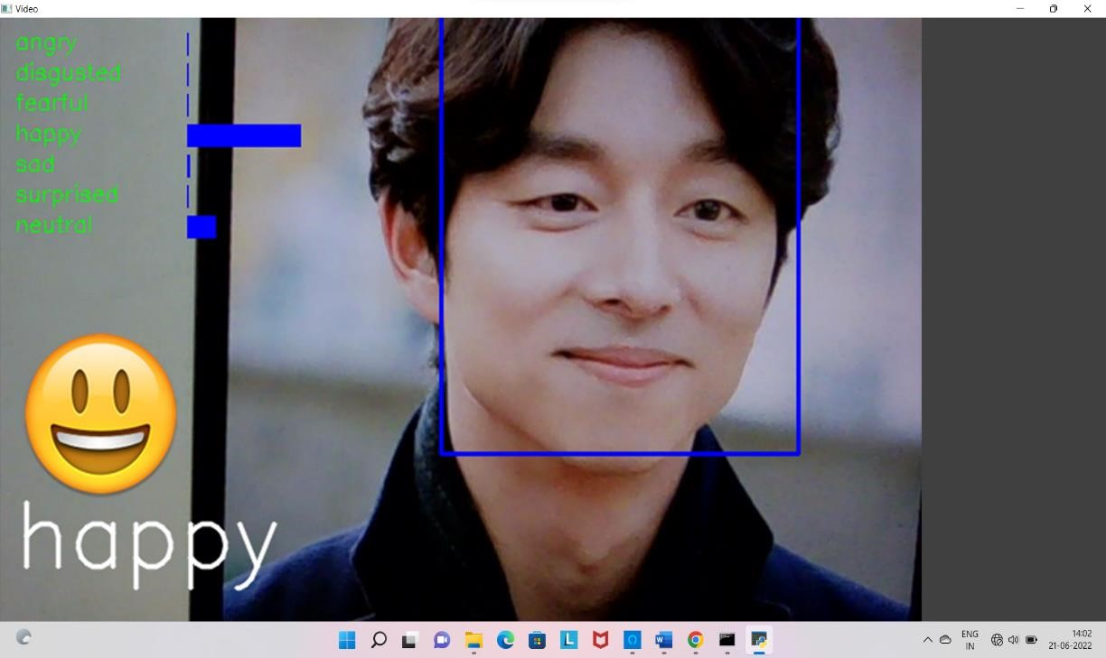

#### Surprised

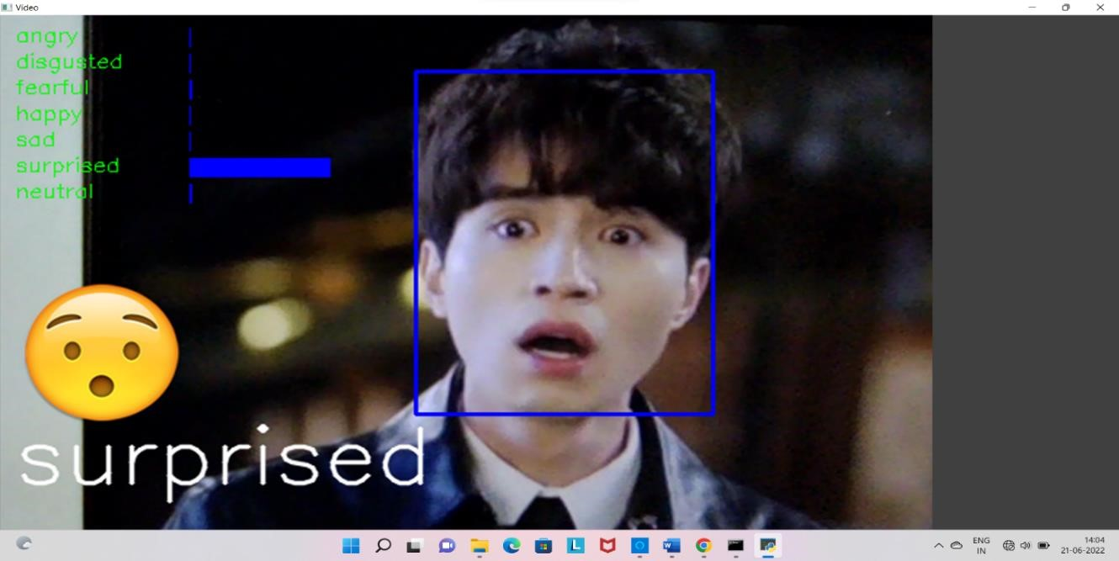

#### Angry

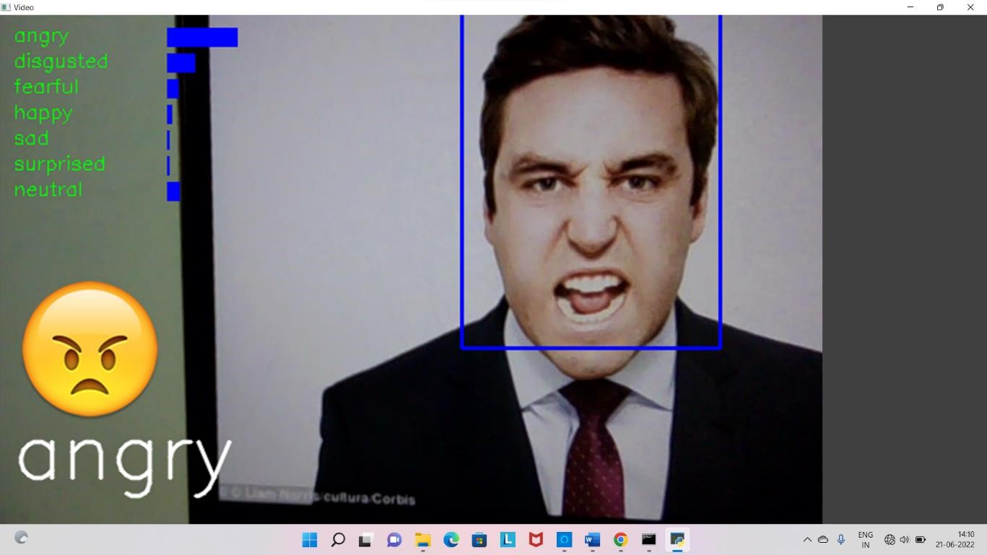

#### Disgusted

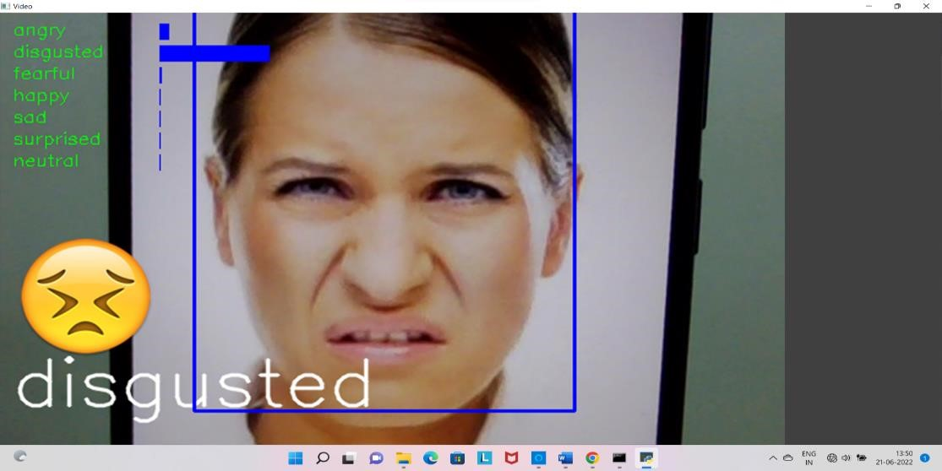

#### Sad

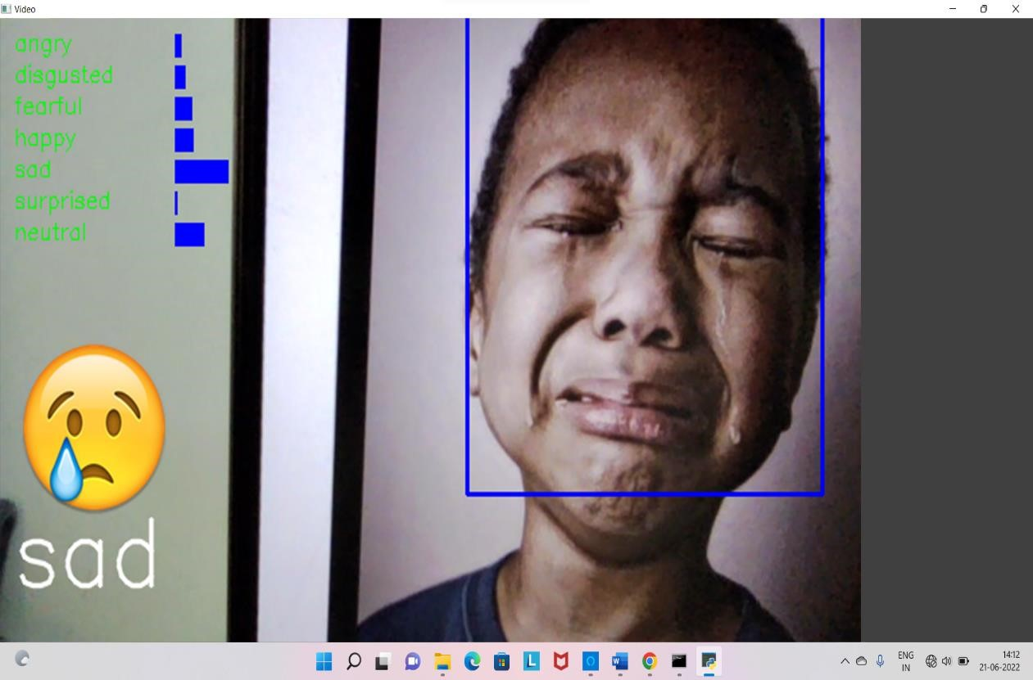

#### Neutral

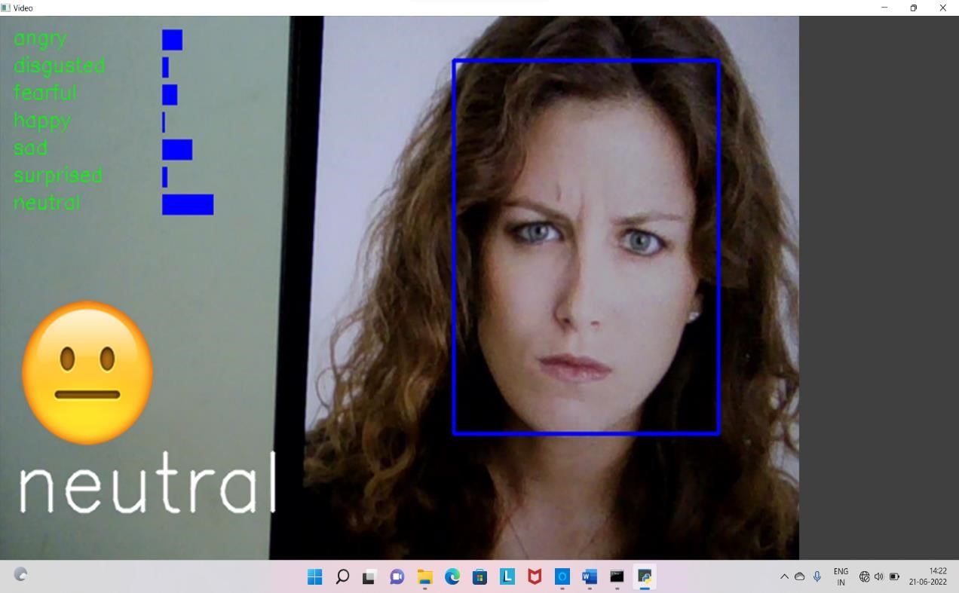

##### 8.3 CONCLUSION AND RECOMMENDATION

###### Conclusion

This project proposes an approach for recognizing the category of facial expressions. Face Detection and Extraction of expressions from facial images is useful in many applications, such as robotics vision, video surveillance, digital cameras, security and human-computer interaction. This project’s objective was to develop a facial expression recognition system implementing the computer visions and enhancing the advanced feature extraction and classification in face expression recognition.

In this project, seven different facial expressions of different persons’ images from different datasets have been analyzed. This project involves facial expression preprocessing of captured facial images followed by feature extraction using feature extraction using Local Binary Patterns and classification of facial expressions based on training of datasets of facial images based on Support Vector Machines. This project recognizes more facial expressions based on JAFFE, COHN-KANADE face database. To measure the performance of proposed algorithm and methods and check the results accuracy, the system has been evaluated using Precision, Recall and Fscore. The same datasets were used for both training and testing by dividing the datasets into training samples and testing samples in the ratio of 8:2 of COHN-KANADE and 7.5:2.5 of JAFFE. The Precision, Recall and Fscore from the COHN-KANADE dataset were 83.6142%, 95.0822% and 88.9955% respectively and JAFFE dataset were 91.8986%, 98.3649% and 95.0218% respectively.

Experiment results on two databases, JAFFE and the COHN-KANADE dataset, show that our proposed method can achieve a good performance. Facial expression recognition is a very challenging problem. More efforts should be made to improve the classification performance for important applications. Our future work will focus on improving the performance of the system and deriving more appropriate classifications which may be useful in many real-world applications.

##### 8.4 Future Scope

Face expression recognition systems have improved a lot over the past decade. The focus has definitely shifted from posed expression recognition to spontaneous expression recognition. Promising results can be obtained under face registration errors, fast processing time, and high correct recognition rate (CRR) and significant performance improvements can be obtained in our system. System is fully automatic and has the capability to work with images feed. It is able to recognize spontaneous expressions. Our system can be used in Digital Cameras wherein the image can be captured only when the person smiles. In security systems which can identify a person, in any form of expression he presents himself. Rooms in homes can set the lights, television to a person’s taste when they enter the room. Doctors can use the system to understand the intensity of pain or illness of a deaf patient. Our system can be used to detect and track a user’s state of mind, and in mini-marts, shopping center to view the feedback of the customers to enhance the business etc.

##### 8.5 References

1. Bettadapura, V. (2012). Face expression recognition and analysis: the state of the art. *arXiv preprint arXiv:1203.6722*.

1. Shan, C., Gong, S., & McOwan, P. W. (2005, September). Robust facial expression recognition using local binary patterns. In *Image Processing, 2005. ICIP 2005.*

*IEEE International Conference on* (Vol. 2, pp. II-370). IEEE.

1. Bhatt, M., Drishti, H., Rathod, M., Kirti, R., Agravat, M., & Shardul, J. (2014). A study of Local Binary Pattern Method for Facial Expression Detection. *arXiv preprint arXiv:1405.6130*.

1. Chi Belushi, C. C., & Burel, F. (2003). Facial expression recognition: A brief tutorial overview. CVonline: On-Line Compendium of Computer Vision, 9.

1. Sokolova, M., Japkowicz, N., & Szpakowicz, S. (2006, December). Beyond accuracy, F-score and ROC: a family of discriminant measures for performance evaluation. In Australasian Joint Conference on Artificial Intelligence (pp. 1015- 1021). Springer Berlin Heidelberg.

1. Michel, P., & El Kaliouby, R. (2005). Facial expression recognition using support vector machines. In The 10th International Conference on Human-Computer Interaction, Crete, Greece.